INDEPENDENT CLAUSES
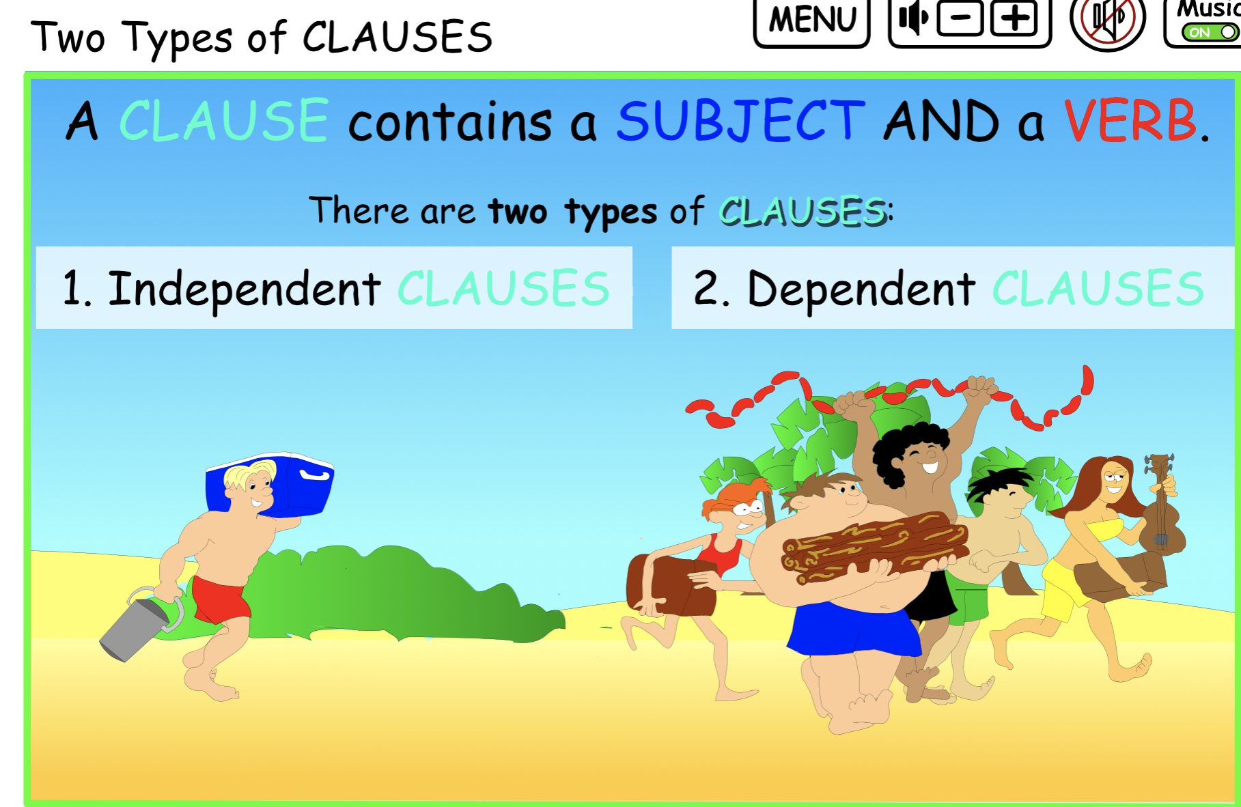
There are 2 main types of CLAUSES:
INDEPENDENT – which can stand alone
DEPENDENT – which require additional words to make sense.
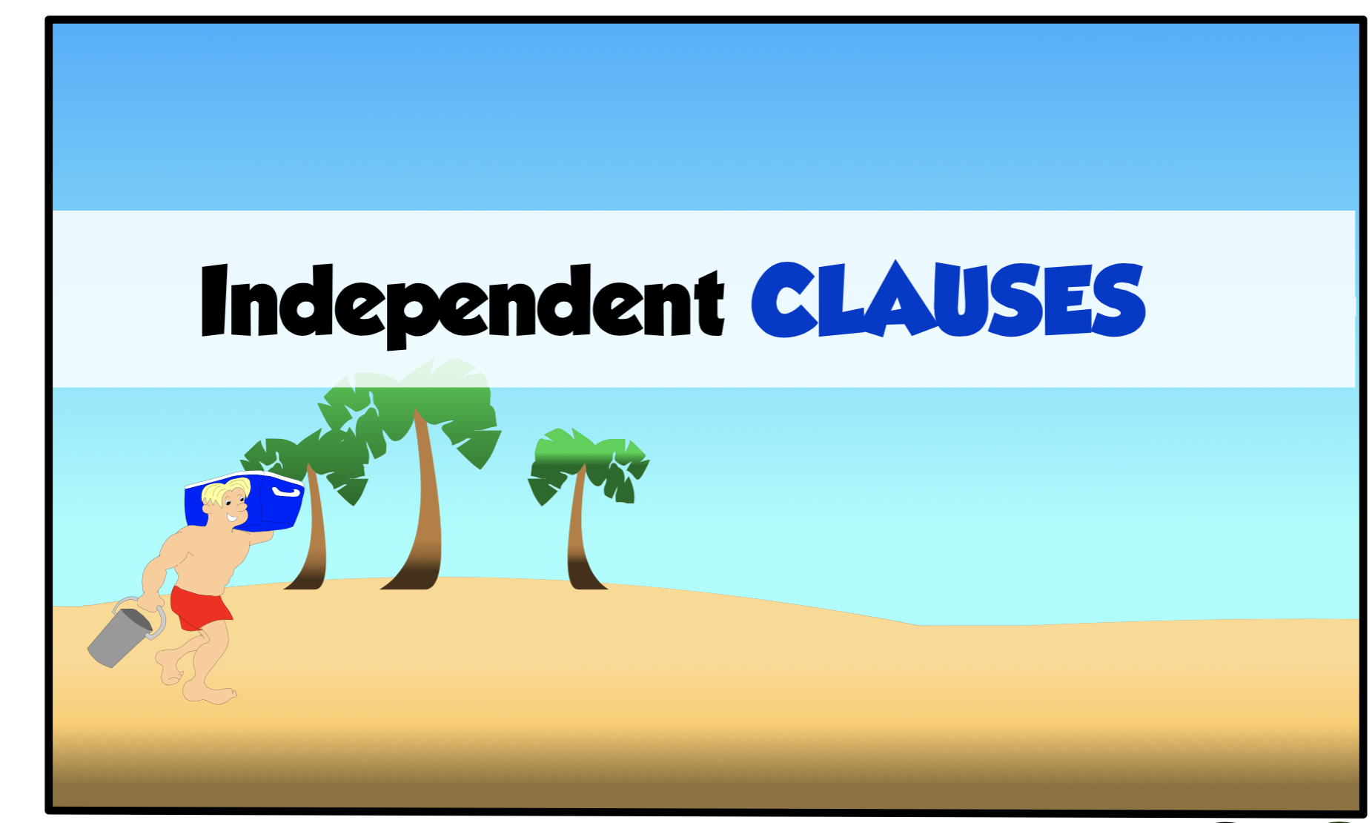

AN INDEPENDENT CLAUSE CAN STAND ALONE.
It contains a SUBJECT and a VERB.

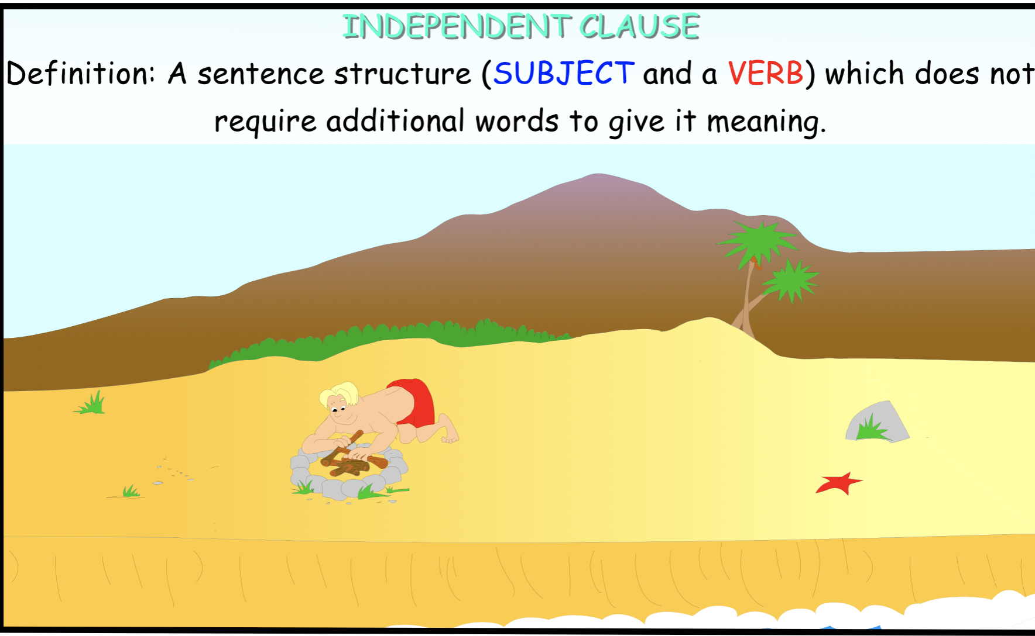
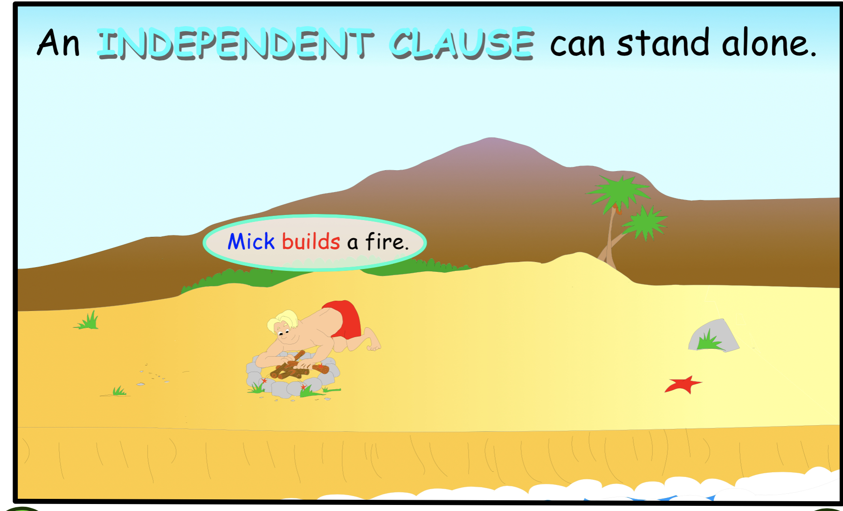

Sentences are INDEPENDENT CLAUSES that begin with
a capital letter and ends with terminal punctuations.

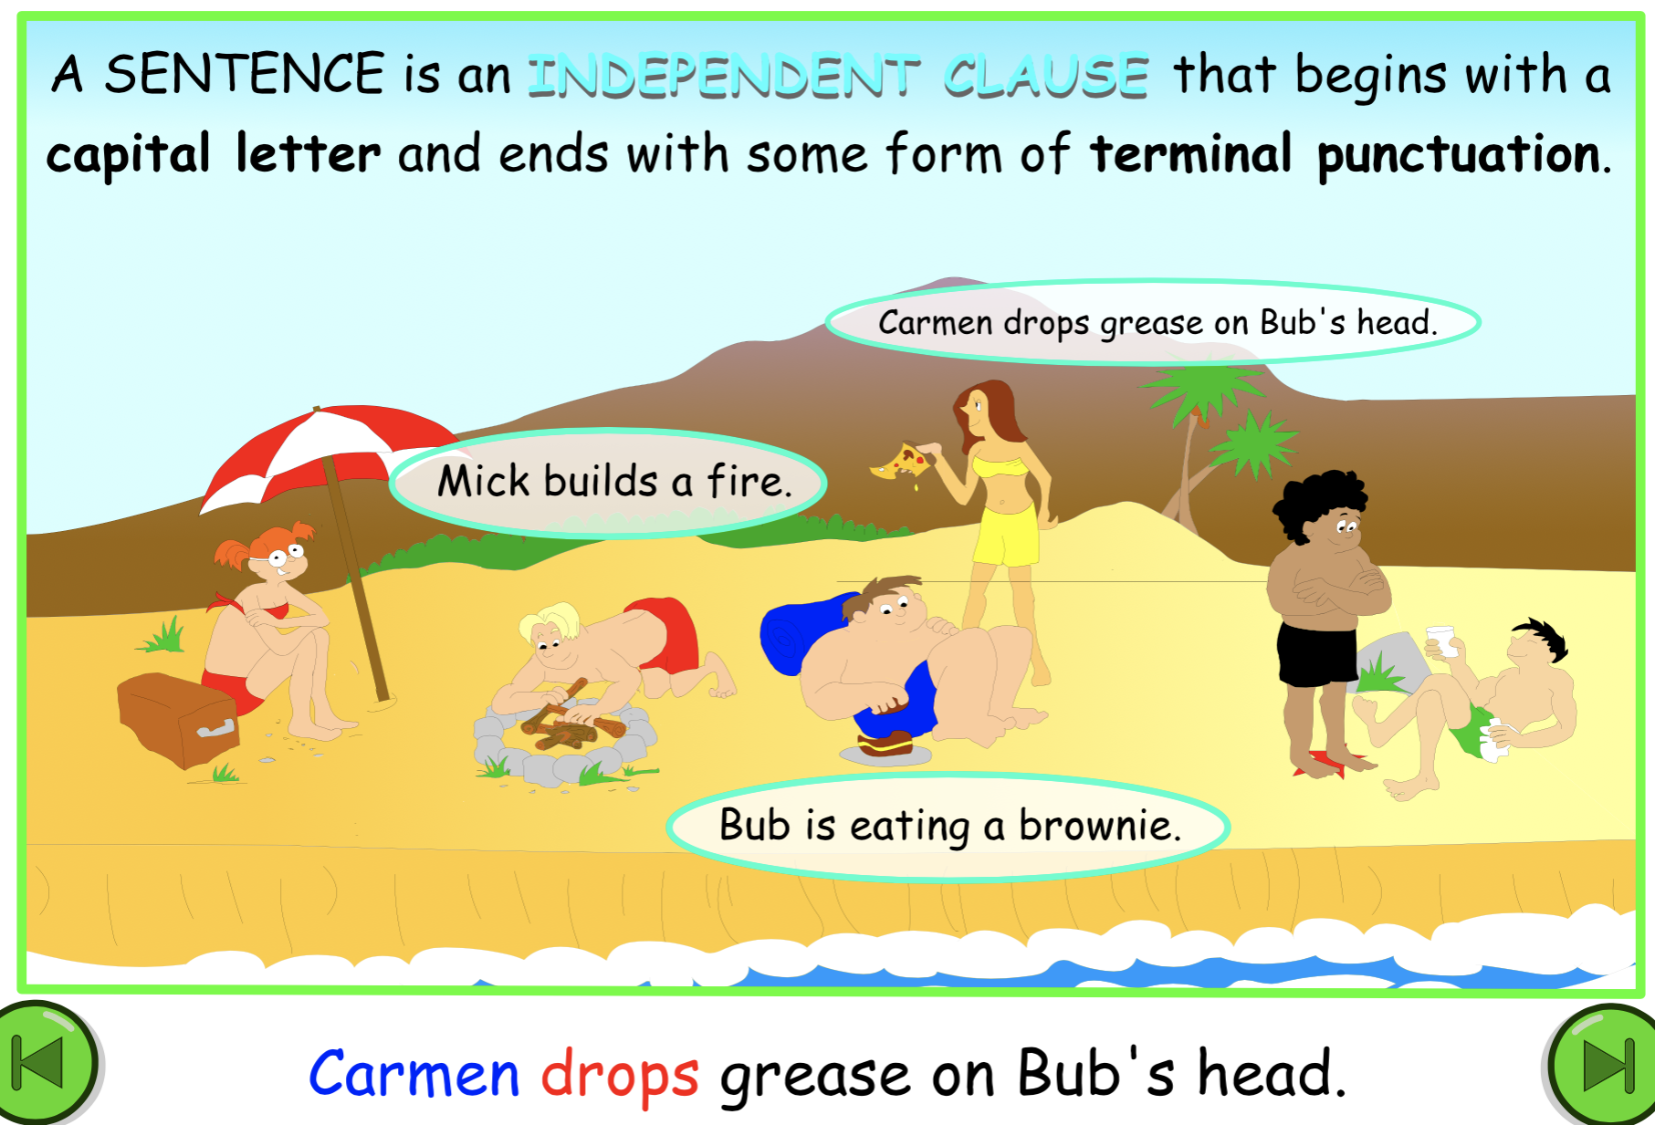

Can you tell the difference between a dependent and an independent clause?

- Swimming across the lake
- Water is overflowing the causeway
- We sank our old rowboat
- That barrowed boat
- Over the next month or more

************************************************************

Answers to the above sentences.

- Swimming across the lake.
- Water is overflowing the causeway. - Independent
- We sank our old rowboat. Independent
- That barrowed boat.
- Over the next month or more.

PRINTABLE QUIZ

IDENTIFY the INDEPENDENT CLAUSES by underlining the SUBJECT once and VERB twice of the complete thought.

- After the storm in the valley.

- 2.Never in my lifetime or in your lifetime.

- Painting always creates some challenges.

- Scurry across the sand.

- Seagulls screech when hungry.

- Seeing the stars shine far in the distance.

- We eat fruit and yogurt in the mornings.

- To run along the beach.

- Waiting for the bus early in the morning.

- Sam will sail the boat here by noon.

QUIZ ANSWERS

ANSWERS: The SUBJECT is underlined once and VERB twice. marked in red.

1. After the storm in the valley.

2. Never in my lifetime or in your lifetime.

3. Painting always creates some challenges.

4. Scurry across the sand.

- Seagulls screech when hungry.

- Seeing the stars shine far in the distance.

- We eat fruit and yogurt in the mornings.

- To run along the beach.

- Waiting for the bus early in the morning.

10.Sam will sail the boat here by noon.

