**THE COMPLETE PREDICATE VERB – The complete VERB of the sentence.**

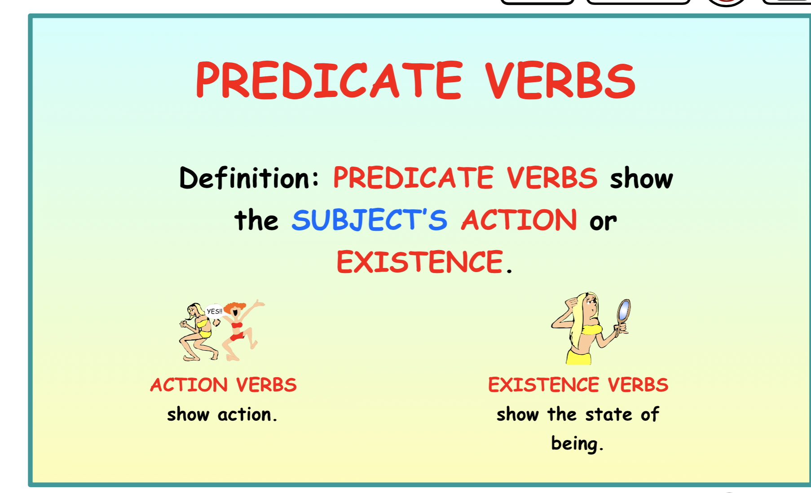

What on Earth is the PREDICATE VERB? Why is it important?

Well, it is ALL the parts of the VERB of a sentence.

A SENTENCE must have a SUBJECT and a VERB.

Our star Sam /wins |the race.

Subject/ Verb| Direct Object (complement)

The PREDICATE VERB is everything in red that comes after the subject,

the verb and all its modifiers

(adjectives, adverbs, and prepositional phrases and complements).

The complements are

DIRECT OBJECT and INDIRECT OBJECT

PREDICATE ADJECTIVE and PREDICATIVE NOMINIATIVE.

Good sentence structures are formed by more than just the single subject and verb.

They are created by expanding the predicate and using modifiers.

Can you recognize the verbs of BE – the most used verbs in the English language?

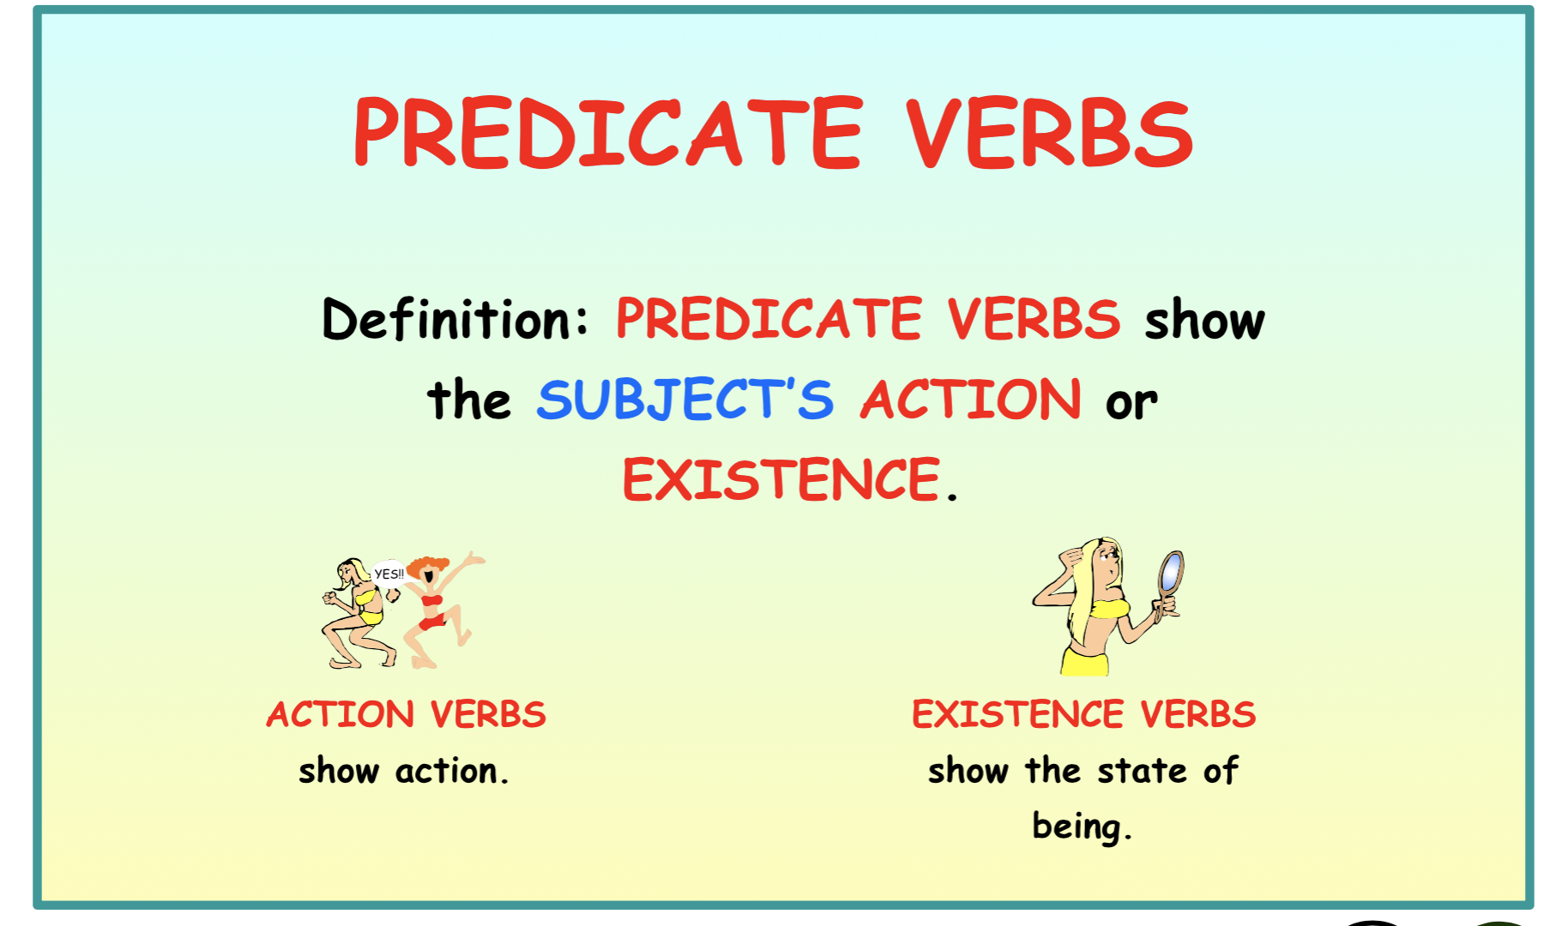

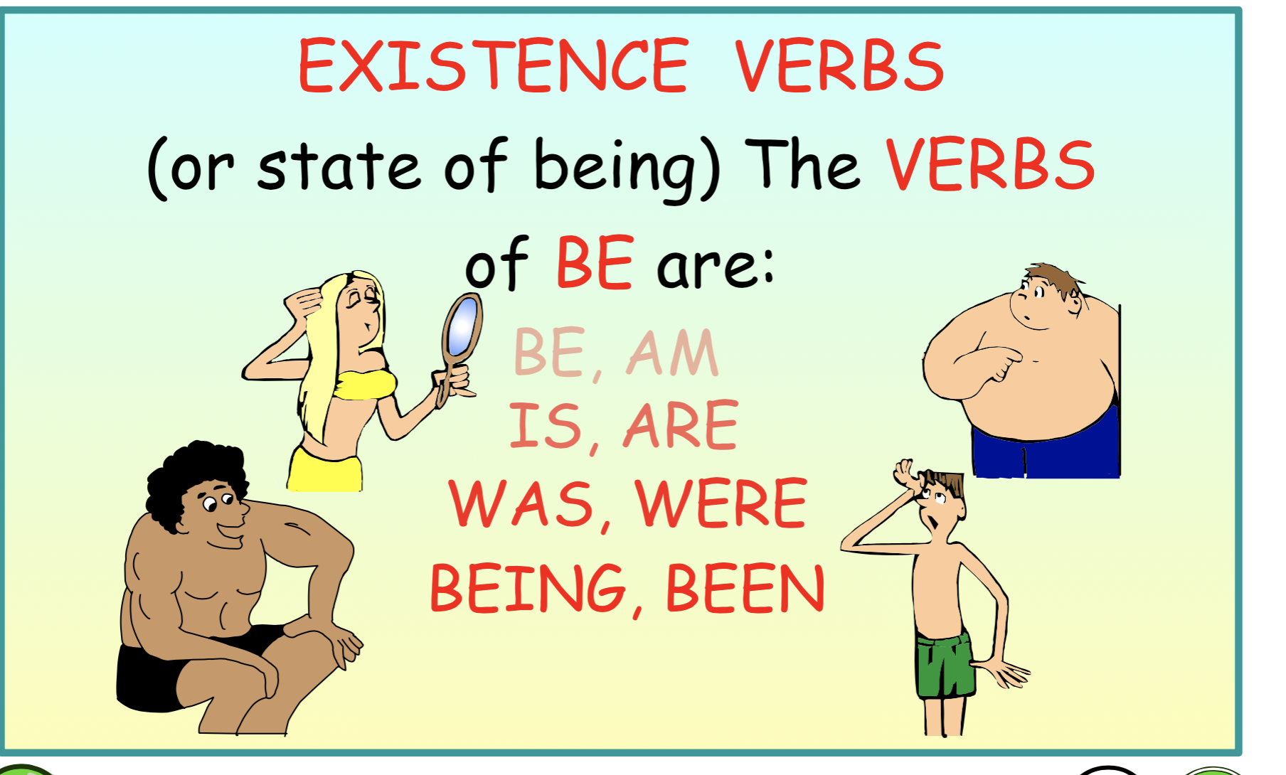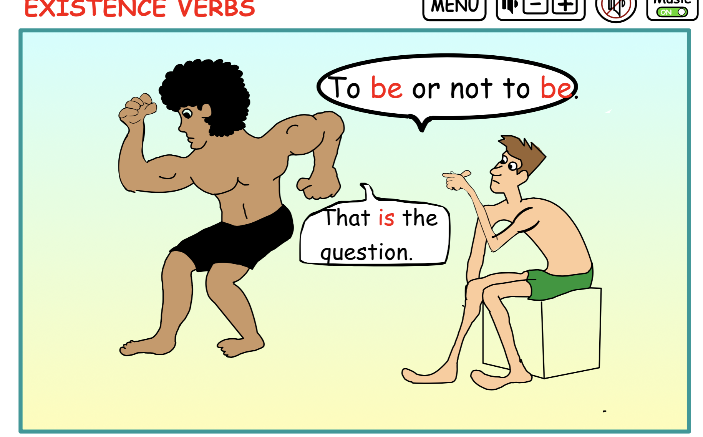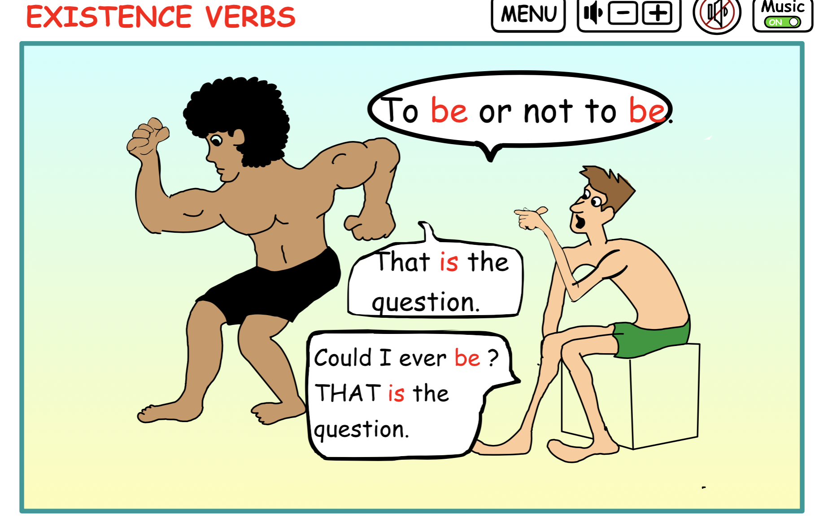

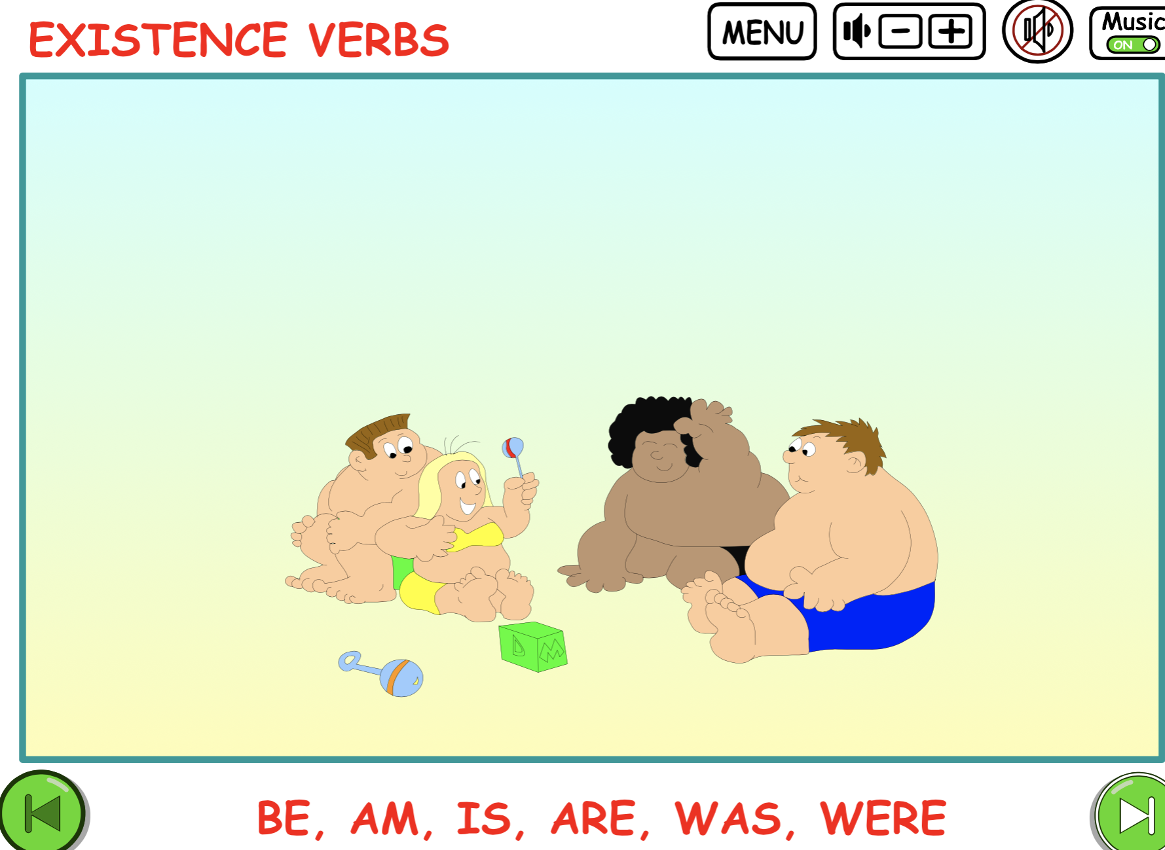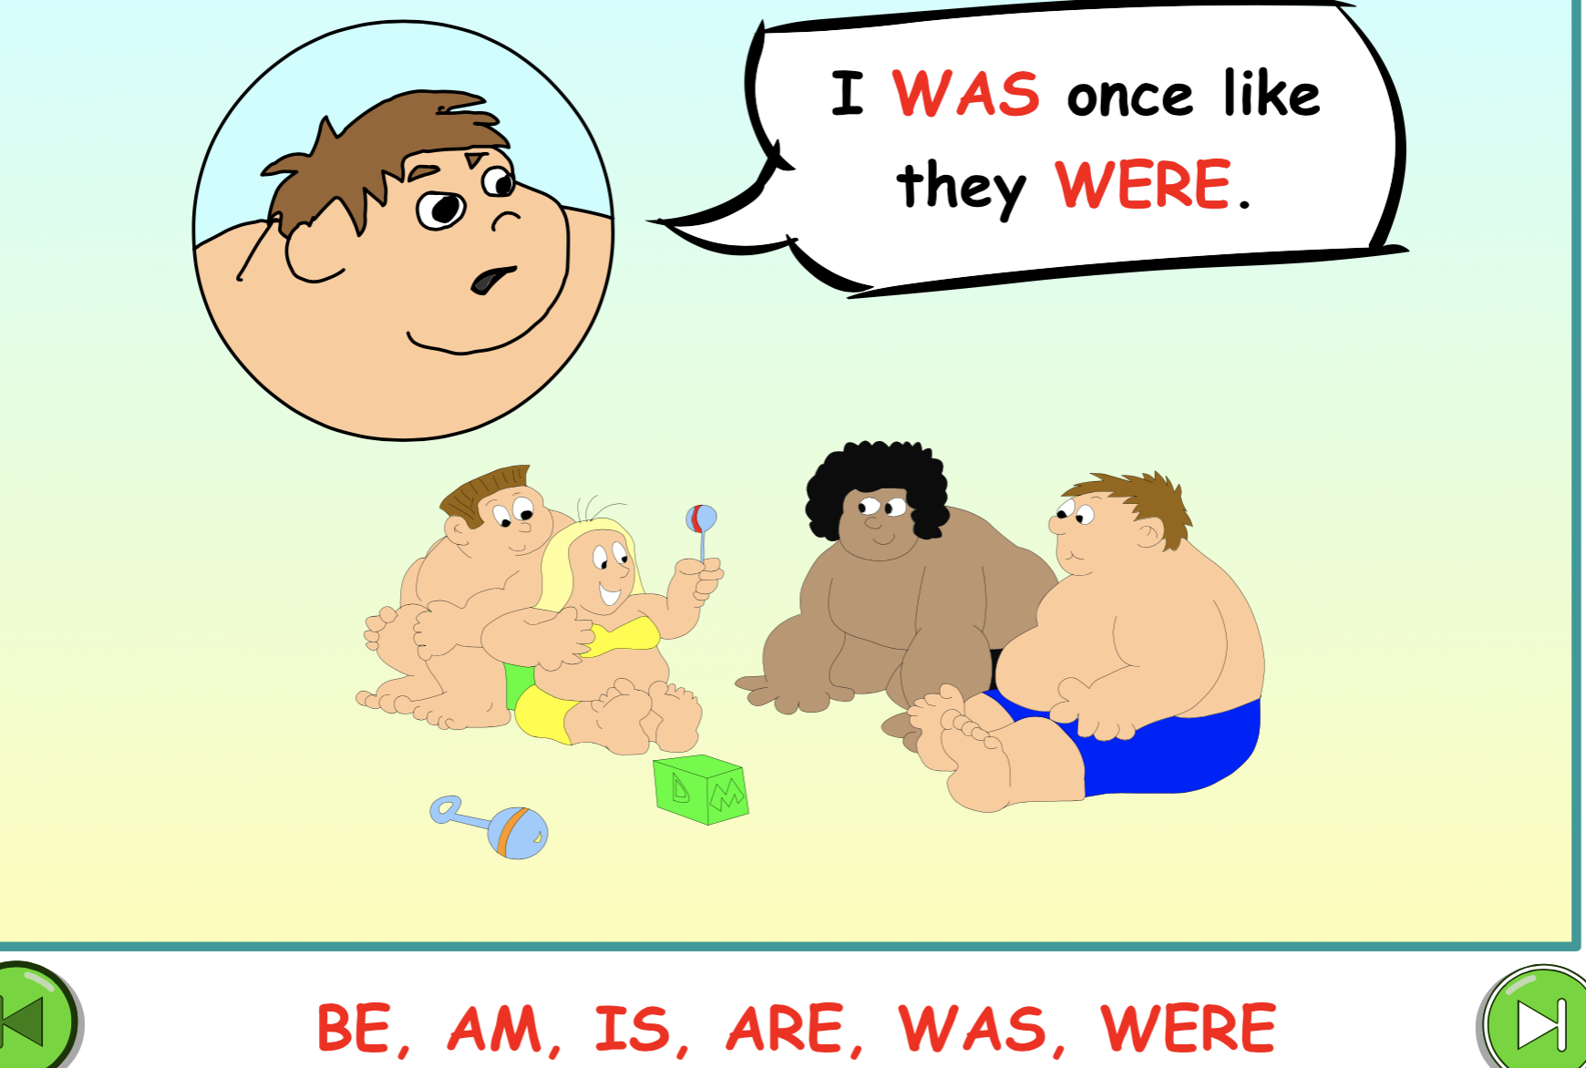

Review the following sentences and notice what parts of the sentence are the PREDICATE.

Note: All the words after the subject are part of the COMPLETE PREDICATE.

All the words inside the (­_) are the parts of the COMPLETE PREDICATE.

SAMPLES:

1. This road (is the bumpiest one in our town.)
2. Your ice chest (was supposed to be left on the dock.)
3. The teams track suits (are blue, white, and red.)
4. You (tripped on that large spike in the deck.)
5. My time (changed for the worse this practice session.)

Directions: Underline and place the entire PREDICATE in paratheses the following sentences.

1. I am the youngest girl in my family.
2. We became the first team to win 10 games in a row.
3. Pro ate three sandwiches for lunch after running 5 miles.
4. Stacy can do five back flips without stopping.
5. Your band plays at the beach shack this afternoon.
6. Twigg will bring her guitar and your banjo.
7. The mountain road is 25 miles to the top.
8. That big rig is too big to back into that space.
9. My canoe flipped when I tried to launch it.
10. Barbie is too busy to come for lunch today.

PREDICATE ANSWERS: Note that everything in red after the subject

is part of the COMPLETE PREDICATATE.

1. I (am the youngest girl in my family.)
2. We (became the first team to win 10 games in a row.)
3. Pro (ate three sandwiches for lunch after running 5 miles.)
4. Stacy (performs five back flips without stopping.)
5. Your band (plays at the beach shack this afternoon.)
6. Twigg (will bring her guitar and your banjo.)
7. The mountain road (is 25 miles to the top.)
8. That big rig (is too big to back into that space.)
9. My canoe (flipped when I tried to launch it.)
10. Barbie (is too busy to come for lunch today.)